**SECTION – 0**

**Section 0 - Use GIT as local VCS. Steps to follow:**

1. Create a directory 'project_dir' & cd to 'project_dir'.

2. Initialize git version database. (git init)

3. Create a new file index.html.

4. Check the git status. You should find index.html as untracked file.

5. Stage the index.html file.

6. Commit index.html

7. Make few changes in index.html & create a new file info.txt file.

8. Check git status. You should find index.html& info.txt as untracked files.

9. Configure GIT to ignore all txt files.

10. Again check the git status. You should find only index.html as untracked file.

11. State & commit index.html

12. Log all your comments so far.

13. Make some changes in index.html.

14. Revert the change made in the previous step using git command.

15. Again change index.html.

16. Stage index.html

17. Revert back the last stage.

18. Rename 'add' command to 'my-add'.

19. Using my_add command Stage index.html again & commit the changes.

20. Revert the last commit.

**QUERY TILL STEPS: 1-9 (**Till Configuring GIT to ignore all txt files)



**QUERY TILL STEPS: 09-19** (Till Staging and Committing index.html File using my_add command instead of add)



**QUERY TILL STEPS: 11-20** (Till reverting the last commit)



**TEXT EDITOR SCREENSHOT AFTER ADDING .GITIGNORE FILE AND ADDING SOME CHANGES IN INDEX.HTML FILE: TILL STEP - 13**

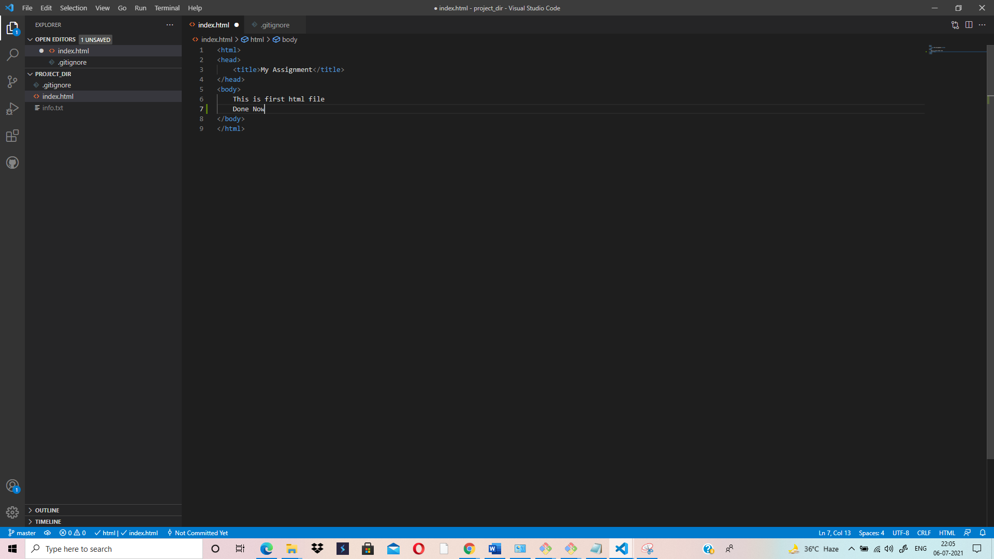

**TEXT EDITOR SCREENSHOT AFTER PERFORMING – (git checkout-- .) – STEP – 14th**

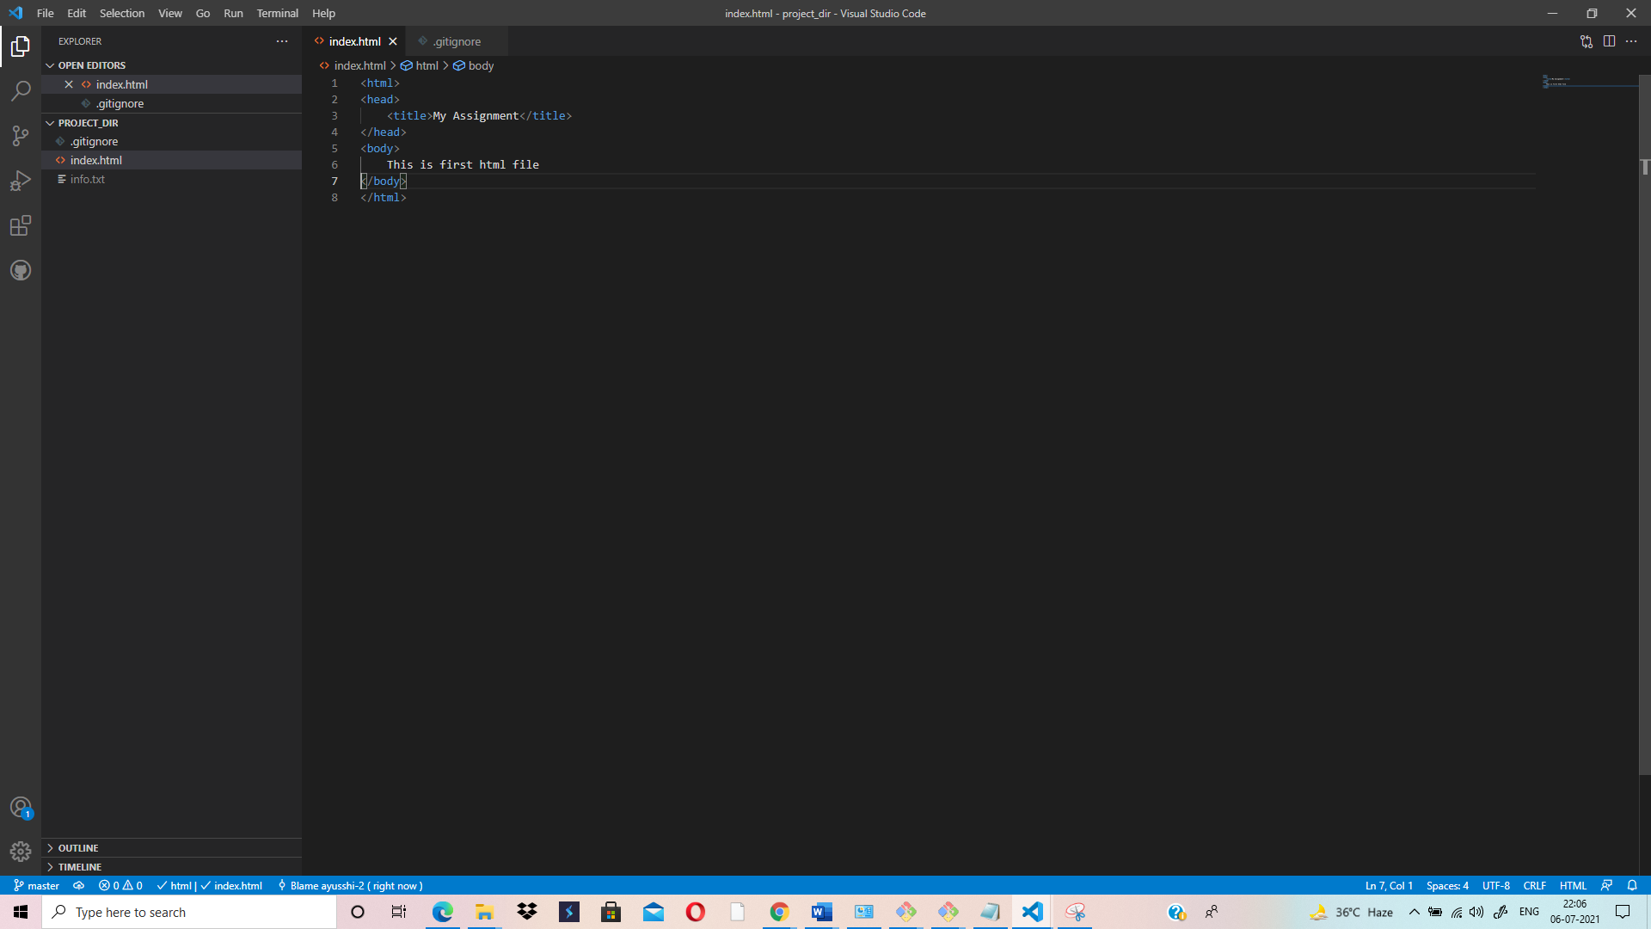

**FULL QUERY SOLUTION:**

SANJAY@AYUSHI-LAPTOP MINGW64 ~

$ cd d:

SANJAY@AYUSHI-LAPTOP MINGW64 /d

$ cd Capgemini

SANJAY@AYUSHI-LAPTOP MINGW64 /d/Capgemini

$ cd Training

SANJAY@AYUSHI-LAPTOP MINGW64 /d/Capgemini/Training

$ mkdir project_dir

SANJAY@AYUSHI-LAPTOP MINGW64 /d/Capgemini/Training

$ cd project_dir

SANJAY@AYUSHI-LAPTOP MINGW64 /d/Capgemini/Training/project_dir

$ git init

Initialized empty Git repository in D:/Capgemini/Training/project_dir/.git/

SANJAY@AYUSHI-LAPTOP MINGW64 /d/Capgemini/Training/project_dir (master)

$ git config --global user.name 'ayusshi-2'

SANJAY@AYUSHI-LAPTOP MINGW64 /d/Capgemini/Training/project_dir (master)

$ git config --global user.email 'onlinetests.papers@gmail.com'

SANJAY@AYUSHI-LAPTOP MINGW64 /d/Capgemini/Training/project_dir (master)

$ touch index.html

SANJAY@AYUSHI-LAPTOP MINGW64 /d/Capgemini/Training/project_dir (master)

$ git status

On branch master

No commits yet

Untracked files:

(use "git add <file>..." to include in what will be committed)

index.html

nothing added to commit but untracked files present (use "git add" to track)

SANJAY@AYUSHI-LAPTOP MINGW64 /d/Capgemini/Training/project_dir (master)

$ git add index.html

SANJAY@AYUSHI-LAPTOP MINGW64 /d/Capgemini/Training/project_dir (master)

$ git commit -m "commit index.html"

[master (root-commit) 4b14571] commit index.html

1 file changed, 0 insertions(+), 0 deletions(-)

create mode 100644 index.html

SANJAY@AYUSHI-LAPTOP MINGW64 /d/Capgemini/Training/project_dir (master)

$ touch info.txt

SANJAY@AYUSHI-LAPTOP MINGW64 /d/Capgemini/Training/project_dir (master)

$ git status

On branch master

Changes not staged for commit:

(use "git add <file>..." to update what will be committed)

(use "git restore <file>..." to discard changes in working directory)

modified: index.html

Untracked files:

(use "git add <file>..." to include in what will be committed)

info.txt

no changes added to commit (use "git add" and/or "git commit -a")

SANJAY@AYUSHI-LAPTOP MINGW64 /d/Capgemini/Training/project_dir (master)

$ touch .gitignore

SANJAY@AYUSHI-LAPTOP MINGW64 /d/Capgemini/Training/project_dir (master)

$ git add .

SANJAY@AYUSHI-LAPTOP MINGW64 /d/Capgemini/Training/project_dir (master)

$ git status

On branch master

Changes to be committed:

(use "git restore --staged <file>..." to unstage)

new file: .gitignore

modified: index.html

SANJAY@AYUSHI-LAPTOP MINGW64 /d/Capgemini/Training/project_dir (master)

$ git add index.html

SANJAY@AYUSHI-LAPTOP MINGW64 /d/Capgemini/Training/project_dir (master)

$ git commit -m "commit changes in index.html"

[master 7eae2c4] commit changes in index.html

2 files changed, 9 insertions(+)

create mode 100644 .gitignore

SANJAY@AYUSHI-LAPTOP MINGW64 /d/Capgemini/Training/project_dir (master)

$ git log

commit 7eae2c4526ebb655e5f842af4ecc150598ddd6ce (HEAD -> master)

Author: ayusshi-2 <onlinetests.papers@gmail.com>

Date: Tue Jul 6 22:03:42 2021 +0530

commit changes in index.html

commit 4b1457136fb90f134f30cb427c57bb8c24efba04

Author: ayusshi-2 <onlinetests.papers@gmail.com>

Date: Tue Jul 6 21:42:34 2021 +0530

commit index.html

SANJAY@AYUSHI-LAPTOP MINGW64 /d/Capgemini/Training/project_dir (master)

$ git checkout -- .

SANJAY@AYUSHI-LAPTOP MINGW64 /d/Capgemini/Training/project_dir (master)

$ git checkout -- .

SANJAY@AYUSHI-LAPTOP MINGW64 /d/Capgemini/Training/project_dir (master)

$ git add index.html

SANJAY@AYUSHI-LAPTOP MINGW64 /d/Capgemini/Training/project_dir (master)

$ git restore --staged index.html

SANJAY@AYUSHI-LAPTOP MINGW64 /d/Capgemini/Training/project_dir (master)

$ git status

On branch master

Changes not staged for commit:

(use "git add <file>..." to update what will be committed)

(use "git restore <file>..." to discard changes in working directory)

modified: index.html

no changes added to commit (use "git add" and/or "git commit -a")

SANJAY@AYUSHI-LAPTOP MINGW64 /d/Capgemini/Training/project_dir (master)

$ git config --global alias.my-add add

SANJAY@AYUSHI-LAPTOP MINGW64 /d/Capgemini/Training/project_dir (master)

$ git my-add index.html

SANJAY@AYUSHI-LAPTOP MINGW64 /d/Capgemini/Training/project_dir (master)

$ git commit -m "commit changes again in index.html"

[master 3184f01] commit changes again in index.html

1 file changed, 1 insertion(+)

SANJAY@AYUSHI-LAPTOP MINGW64 /d/Capgemini/Training/project_dir (master)

$ git status

On branch master

nothing to commit, working tree clean

SANJAY@AYUSHI-LAPTOP MINGW64 /d/Capgemini/Training/project_dir (master)

$ git reset --soft HEAD~1

SANJAY@AYUSHI-LAPTOP MINGW64 /d/Capgemini/Training/project_dir (master)

$ git status

On branch master

Changes to be committed:

(use "git restore --staged <file>..." to unstage)

modified: index.html

SANJAY@AYUSHI-LAPTOP MINGW64 /d/Capgemini/Training/project_dir (master)

$